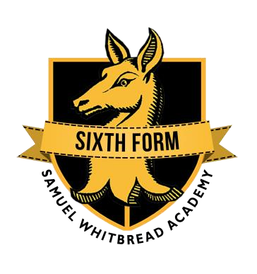Sixth Form students: Believe – Achieve – Succeed - Exceed



**INDEPENDENT LEARNING AND PRIVATE STUDY**

**RESOURCES/READING LISTS**

1. Recommended text book/resources
2. Resources to purchase in order to support your progress
3. Recommended text books and resources that should be used as part of your independent reading and note taking
4. Recommended MOOCs (Massive Open Online Courses) to support studies in the course

|  |  |  |  |
| --- | --- | --- | --- |
| **Course/Subject** | **Recommended text book/resources to purchase** | **Recommended resources for extra reading and note taking** | **Recommended MOOC to support learning in this**  **course** |
| **Philosophy, Religion & Ethics**  **(WJEC EDUQAS Religious studies)** | **Year 12:**  Philosophy & Ethics: <https://www.illuminatepublishing.com/product/wjec-eduqas-religious-studies-for-a-level-year-1-as-philosophy-of-religion-religion-and-ethics>  Buddhism: <https://www.illuminatepublishing.com/product/wjec-eduqas-religious-studies-for-a-level-year-1-as-buddhism>  **Year 13:**  Ethics: <https://www.illuminatepublishing.com/product/wjec-eduqas-religious-studies-for-a-level-year-2-a2-religion-and-ethics>  Philosophy: <https://www.illuminatepublishing.com/product/wjec-eduqas-religious-studies-for-a-level-year-2-a2-philosophy-of-religion>  Buddhism: <https://www.illuminatepublishing.com/product/wjec-eduqas-religious-studies-for-a-level-year-2-a2-buddhism>  **Electronic revision textbooks:**   * My Revision Notes: WJEC and Eduqas A level Religious Studies Philosophy of Religion <https://amzn.eu/d/ezIV2Dj> * My Revision Notes: WJEC and Eduqas A level Religious Studies Religion and Ethics <https://amzn.eu/d/ik3Sz3C> | **PHILOSOPHY – Wider Reading**   * Plato – *The Republic, The Death of Socrates* * Aristotle – *Poetics, The Nichomachean Ethics.* * David Hume – *An Enquiry Concerning Human Understanding, Dialogues Concerning Natural Religion* * Thomas More – *Utopia* * J.S. Mill – *Utilitarianism* * Michel de Montaigne – *Collected Essays* * Friedrich Nietzsche – *Beyond Good and Evil, The Birth of Tragedy, Thus Spoke Zarathustra* * Søren Kierkegaard – *Fear and Trembling* * Albert Camus – *The Myth of Sisyphus, The Rebel, The Fall* * Jean-Paul Sartre – *Being and Nothingness, What is Literature?* | All past papers can be found here:   * <https://www.eduqas.co.uk/qualifications/religious-studies-as-a-level/#tab_pastpapers>   Here you can find lots of free revision aids including videos and summaries plus extra ones to purchase if necessary (Second link is specifically for Buddhsim):   * <https://www.qehs.carms.sch.uk/media/bsikydgs/as-level-religious-studies.pdf> * <https://resource.download.wjec.co.uk/vtc/2017-18/17-18_2-20/pdf/eduqas/Eduqas%20Buddhism.pdf>   The following is a revision website which provides lots of useful resources and notes:   * <https://alevelphilosophyandreligion.com/eduqas-wjec-religious-studies/>     All Knowledge organisers from the exam board can be found here:   * <https://resources.eduqas.co.uk/Pages/ResourceSingle.aspx?rIid=1430>   Lytchett PRE Youtube channel is helpful, below is a link for exam structure, but if you go onto the playlists there are many helpful breakdowns for the A-level themes.   * <https://www.youtube.com/watch?v=U4xYboDULdw>   A philosophy podcast on spotify to get your mind thinking:   * <https://open.spotify.com/show/2Shpxw7dPoxRJCdfFXTWLE> |